Application Form
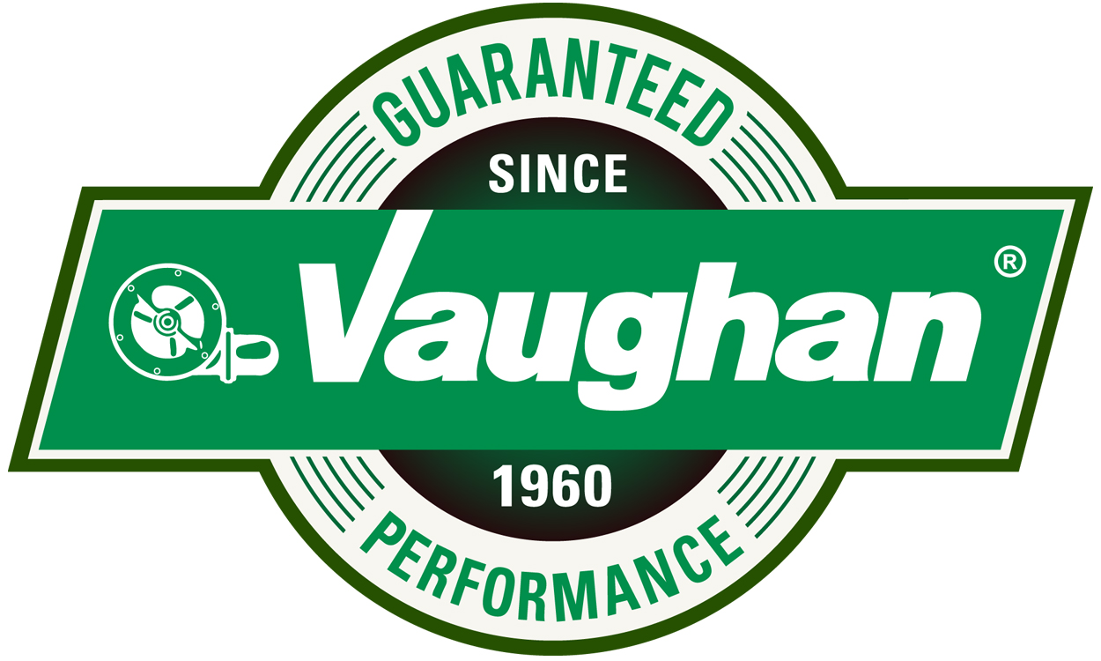
For Vaughan Co., Inc. $1,000 Minimum Scholarship

ELIGIBILITY: The applicant may be any Elma or Montesano School District graduate, regardless of graduation year, planning to pursue a post-secondary degree or vocational/technical certificate.

The applicant should be aware that our choice will not be limited to low income. Payment will be made directly to the school of your choice of enrollment.

Applications Due Date: March 29, 2024

Please include the following items:

- Completed Application Form
- At least one Letter of Recommendation
- Transcript
- One-page Personal Essay

- Resumé (please include academic honors, awards, memberships, extracurricular activities, clubs, work experience volunteer experience, hobbies, etc.)

Please return in person, by standard mail or email:

Vaughan Co., Inc.
364 Monte Elma Rd.
Montesano, WA 98563
scholarships@chopperpumps.com

Name_____________________________________Date of Birth_________________________________
Mailing Address_______________________________________________________________________
E-mail____________________________________ Phone Number______________________________
High School GPA_________ College or Vocational / Technical GPA (If Applicable) _________
Graduate of: ○ Elma ○ Montesano Graduation Year:_______________________
Name of college, university, or accredited technical or vocational school you plan to attend.
____________________________________________________________________________________
Do you have any financial assistance available? How do you plan on financing your education? __________________________________________________________________________________________________________________________________________________________________________
_____________________________________________________________________________________
Intended area of study and/or college major__________________________________________________
TURN OVER
Personal Essay Requirements

- What is your post high school education plan?
- What activities and interests have you been involved in what will help you achieve your education and career goals?
- Why do you believe you will be successful in achieving your educational goals?
- How will you apply your skills gained upon completion of your degree?
- Why do you believe you will be successful in your chosen career path?
- How will your chosen career path allow you to give back to your community?
- Please also include any extenuating circumstances that may assist the scholarship committee in making their decision.

Application Signature

I hereby certify that the information given on the opposite side and attached to this application form are true and accurate to the best of my knowledge.

Applicant’s Signature_________________________________________Date:_______________

